September 2022

Dear Parents/Carers,

PERMISSION TO VISIT THE COMMON / WOODS

During your child’s school years at Antingham & Southrepps Primary School, there will be many opportunities for them to visit the common/woods opposite the school for Outdoor Learning sessions.

Please sign the permission slip below and return to school.

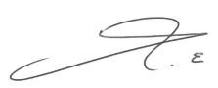
Yours sincerely,

Mr Elcock
Headteacher

PERMISSION TO VISIT THE COMMON / WOODS

I give permission for my son/daughter .…………………………..…..................…………………… to visit the common/woods.

Signature: ……………………………………………………..............…………(Parent/Carer)

Date: ………………………….....................….……

